Overview on UI design and sequence diagram

Group 234

**Sequence diagram:**

**Members:**

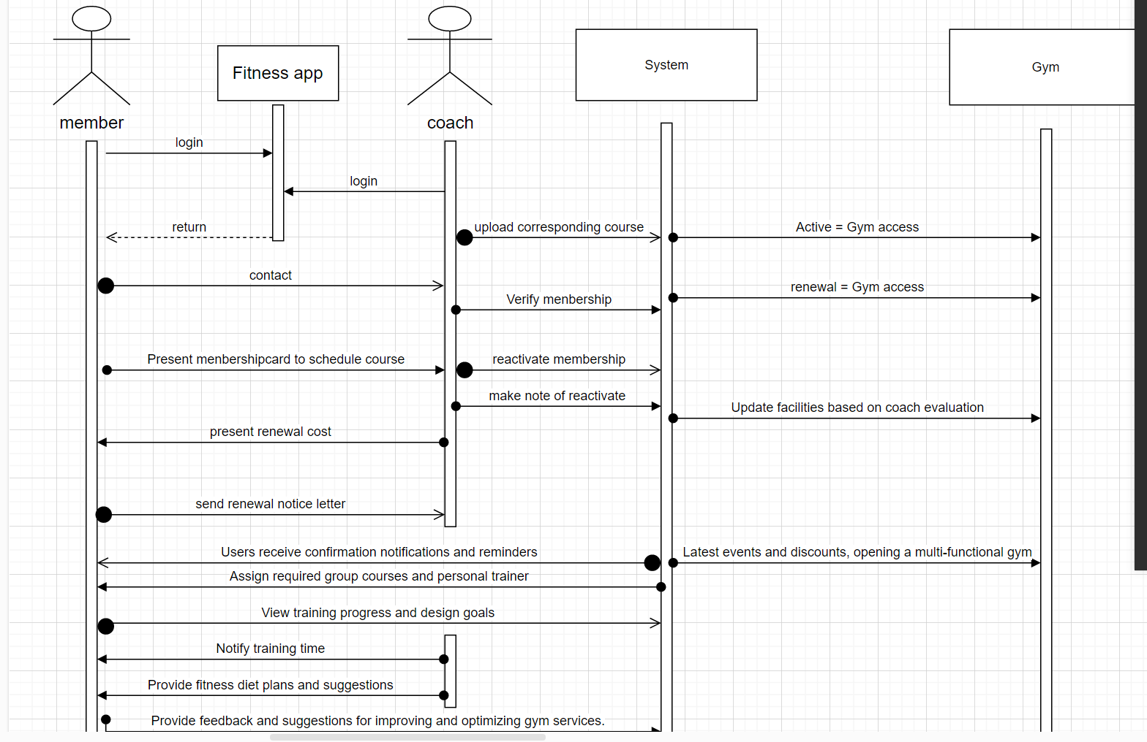

**Coach:**

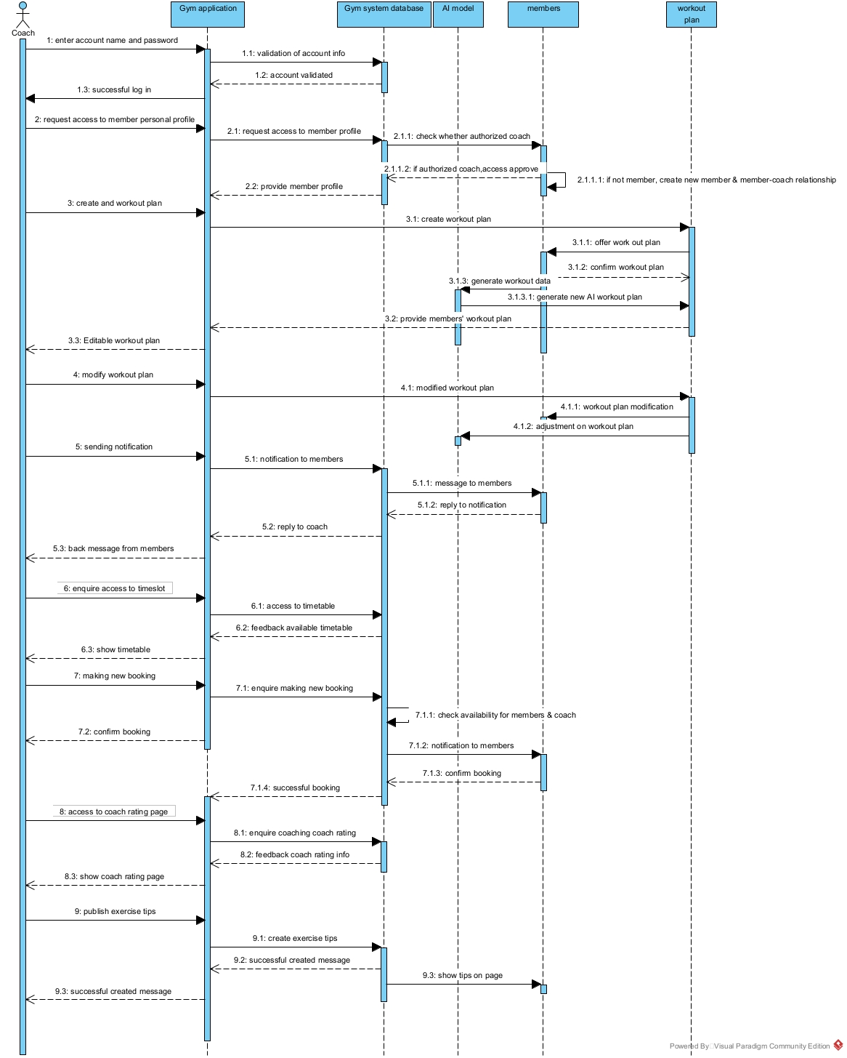

**Admin:**



**UI design**

Since we used Figma as our UI design platform, here is the link for each part design. (Internet needed)

**Coach:**

<https://www.figma.com/file/RtvzrldutaoOGrrw0VRvk8/Material-Symbols-(Community)-(Copy)?node-id=0%3A1&t=3wEc1I7ZQdFCoOqh-1>

**Admin:**

<https://www.figma.com/file/SvJeXy6pePKZsGH6UU1brc/998?node-id=0%3A1&t=rxy5qu05aVNQhfh0-1>

**Members:**

[**https://www.figma.com/file/Zc17WY7liyhI1zHTKF0T9t/Untitled?node-id=0%3A1&t=lBA01Q9iYhleSYlX-1**](https://www.figma.com/file/Zc17WY7liyhI1zHTKF0T9t/Untitled?node-id=0%3A1&t=lBA01Q9iYhleSYlX-1)